Scala programming

Lab assignment

Name – chaithanya gowda l

Usn – 22btrad010

Problem Statement :Write a Scala program that creates an enum class Color with values for different colors. Use the enum class to represent an object's color.

ALGORITHM:

1. **Define the Color trait and case objects:**
   * Define a sealed trait **Color** and case objects **Red**, **Green**, **Blue**, and **Orange** that extend the **Color** trait.
2. **Create a ColorApp object:**
   * Create an object named **ColorApp** to contain the main method and additional methods for printing the color.
3. **Define the main method:**
   * Define the **main** method within **ColorApp** to demonstrate the usage of the **Color** enum-like values.
4. **Print the color using the printColor method:**
   * Call the **printColor** method to print the color based on the provided **Color** enum-like value.

INPUT:

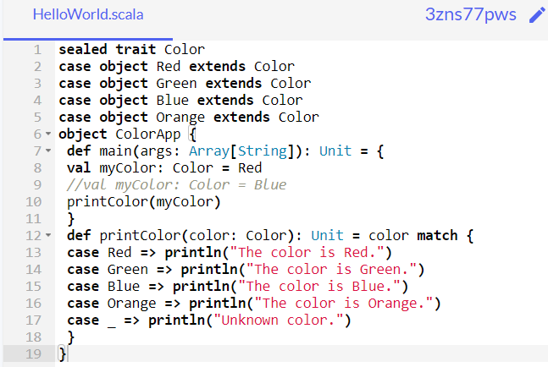

OUTPUT:

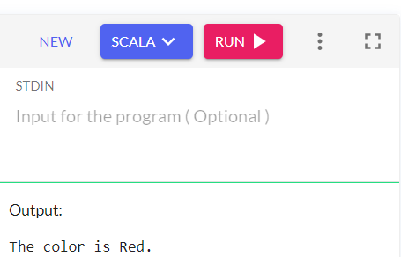

INPUT:

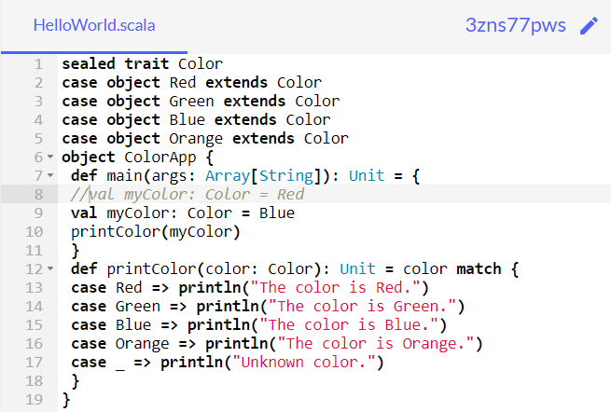

OUTPUT:

